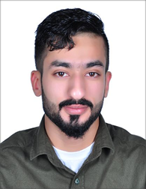CURRICULUM VITAE

HUSSAIN RADHI JASIM AHMED HAZEEM

Mob. +973 38990565

Email: hussianhazeem98@gmail.com

CAREER OBJECTIVE

To strive for a challenging job in a progressive organization, where I can contribute and build my career along with the growth and to give the best of my experience and abilities.

PERSONAL PROFILE

|  |  |
| --- | --- |
| Date of birth | 18 June 1998 |
| Sex | Mail |
| Marital status | Single |
| Nationality | Bahrain |
| CPR No | 980606071 |
| Driving License Bahrain | valid |
| Present Address | Flat: Road:7526 Block: 575, Bldg. 1870  Al-Janabiyah— Kingdom of Bahrain |

LANGUAGES

* Arabic and English

EXTRA CURRICULAR ACTIVITIES

*Computers, Microsoft Media, Sports

STRENGTH

*Self-confidence, interpersonal skills, good communication skill, physically fit, ability to be responsible, organization and handle pressure, ability to work hard.

WORK EXPERRIANCE

Worked as a Manager at Real Estate Company in Bahrain

DECLARATION

I hereby solemnly affirm that all details provided above are true to the best of my knowledge and belief and that all the time, I shall carry myself in a manner that lends dignity to the organization and worthy enough of the person.

**HUSSIAN RADHI JASIM AHMED HAZEEM**